NAME : THATIGOTLA VENKUTA KAZHITHH

CLASS : CIVIL -A

YEAR- 1st YEAR

SUBJECT:SOFTWARE DEVELOPMENT PRACTIES

CODE:24CS102

COLLEGE:R.M.K ENGINEERING COLLEGE

Software Requirements Specification (SRS) For Seminar Hall Booking Website

1.Purpose
The purpose of the Seminar Hall Booking System is to automate and streamline the process of reserving seminar halls for various events.

2.Scope
The Seminar Hall Booking allows users to view availability and request bookings, while administrators can approve, reject, or modify bookings.
The System Enable
1.Hall – free booking process.
2.Real time uptade on hall availability.
3. Benefits
1.Avoid double-booking.
2.Save time and effort.
3.Maintain proper record for future.
4. User Classes and Characteristics
1.Admin:
1.Approve or Reject the booking request.
2.Manage the seminar Hall detail.
3.Can block the hall booking for maintance.
2.User:
1. Can log in and view hall availability.
2.Can submit hall booking requests with event details (date, time, purpose).
3.Receives approval/rejection notifications.
4.Can cancel or modify bookings.
5. Specific Requirements
1.Functional Requirements
1. View seminar hall availability.
2.Submit, modify, or cancel booking requests.
3.Admin approval/rejection workflow.
4. Notifications via email/SMS for confirmations.
2.Non Functional Requirements
1. Performance: Response time < 3 seconds.
2. Security: Only authenticated users can access the system.
3. Usability: Easy support for mobile and webpage.
3.External Interface Requirements
1. User Interface: Simple dashboard for users, admin control panel for administrators.
2. Hardware Interface: Standard desktop, laptop, or mobile device.
3. Software Interface: Database connection (MySQL/Oracle).
6. System Model

Entity Releationship Model
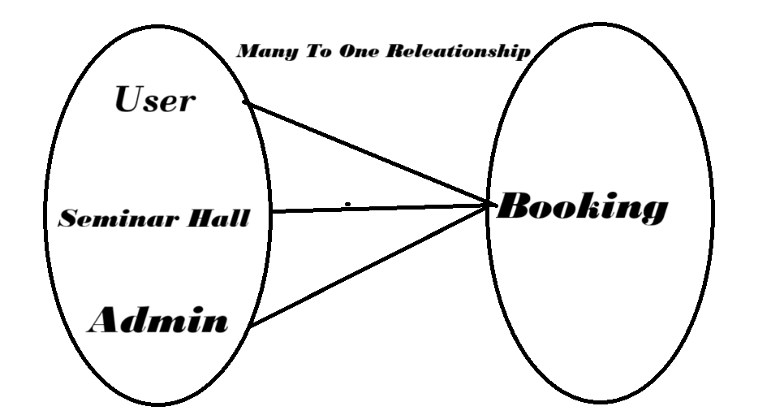

7. Appendix
1. Future scope: Integration with mobile app support.
2. Limitations: Currently designed for small Seminar Hall only.

Thank You

